[1]

Project Proposal-Preparation for Migration to Cloud for Smaller Enterprise Businesses

Andrew Abbott, Nathan Mowat, and Tracie Scott

*Abstract*—The migration to cloud for Fortune 500 and other global entities is achieved by engaging with top consulting companies and experienced professionals from the cloud providers themselves. For companies for whom that level of support is out of reach, what are the most effective methodologies and best practices to assure a successful, non-disruptive transition to cloud? This paper outlines a playbook for a smaller Enterprise or SMB organizations to migrate operations from on premise to cloud. Our discussion creates a basic understanding of cloud terminology and service options, present a migration project management framework and present some relevant migration options.

*Index Terms*- cloud migration, rehosting, AWS, Azure, SnowBall, CloudEndure

# introduction

F

or this project, we will interview migration leads from two companies currently engaged in migration planning to understand their concerns and explore how they have planned and prepared for the migration. We will compare offerings from top cloud providers to present a ‘buyer’s guide’, highlighting the availability of professional assistance. The team will conduct a literature review to collect best practices and methodologies reported for cloud migration both in scholarly papers and in respected professional journals. Our search will include publications from the last six months (May ’17 – ‘Sept 17). Based on the research, we will create a migration planning guide to provide a Do-It-Yourself reference tool for smaller Enterprise operations transitioning to cloud.

Larger businesses have more resources and infrastructure to facilitate innovation adoption [1]. SMBs suffer from “Resource poverty” due to various conditions unique to SME, such as operating in a highly competitive environment, financial constraints, lack of professional expertise Consequently, SMB face substantially more barriers to adoption of cloud computing than large businesses. This paper is designed to provide a guidebook to cloud migration methodologies to assist SMB organizations overcome this situation and conduct successful cloud migrations.

## What is Cloud Computing

According to the [Cisco Global Cloud Index](http://www.cisco.com/c/dam/en/us/solutions/collateral/service-provider/global-cloud-index-gci/white-paper-c11-738085.pdf) [2], cloud-based data centers will process 92 percent of enterprise workloads by 2020 [2]. Many sources state that any service provided over the Internet is a cloud service. However, that is not technically accurate as services were provided over the Internet for decades before the ‘cloud’ was recognized. The use of commodity hardware and virtualization to provide horizontally scalable services over the Internet distinguish cloud infrastructures from older approaches. Technically, services can still be offered over the Internet without the key traits that distinguish a true cloud offering from an older architecture, although that is becoming increasingly rare. Cloud-based services are generally recognized to provide the following key traits.

[**Self-service provisioning**](http://searchcloudprovider.techtarget.com/definition/User-self-provisioning)**:** End users can spin up resources [on demand](http://searchitoperations.techtarget.com/definition/on-demand-computing). This eliminates the traditional need for IT administrators to provision and manage resources.

[**Elasticity**](http://searchcio.techtarget.com/definition/IT-elasticity)**:** Companies can scale up as needs increase and scale down again as demands decrease. This eliminates the need for massive investments in local infrastructure, which may or may not remain active.

[**Pay per use**](http://searchcio.techtarget.com/definition/metered-services)**:** Resources are measured at a granular level, enabling users to pay only for the resources and workloads they use.

**Workload resilience:** Cloud service provider offer redundant resources to ensure resilient storage and to keep users' important workloads running -- often across multiple global regions.

**Migration flexibility:** In theory, organizations can move certain workloads to or from the cloud -- or to different cloud platforms -- as desired. Because providers may have termination fees and moving large datasets and/or critical applications may be problematic, this trait may not be fully realized.

## Why move to Cloud

The key traits that define the cloud also provide the key benefits for moving to cloud. Unlike traditional IT models, which may require weeks or months to provision new hardware and build a stack to support a new application, cloud providers make services available quickly and easily. For quick trials or to manage episodic peaks in demand, leveraging cloud may be cheaper than purchasing and provisioning resources that normally would not be fully utilized.

**Cost:** Cloud solutions allow for substantial savings and flexibility to mitigate periods of peak resource utilization or for instances when an environment will have a short-term use, perhaps for a prototype environment.

**Specialty Skills:** Especially for smaller organizations, leveraging cloud services alleviates the need to hire specialized IT resources. Services can be easily and quickly provisioned in the cloud without the need for experts and the infrastructure is maintain and upgraded by the service provider. In addition, the cloud providers frequently have access to the industry leading experts in security, networking, infrastructure, and application deployment that are unavailable to the majority of organizations.

**Focus:** Allows focus on core projects and programs as opposed to IT infrastructure projects that are not part of their strategic differentiation.

**Simplicity:** Removes the complexities of maintenance, such as patches and upgrades, as well the need to stay abreast of the latest products and trends.

## Reasons to defer move to Cloud

**Security:** Most cloud infrastructures feature a shared architecture. As services are provided, many of the details of that service that would be controlled by your staff become transparent or invisible. Where is backup data stored? What happens to the data on a disk when the disk is replaced? Could data that is legally required to remain in-country be backed up to a target across the border? How trustworthy are the provider’s employees that have access to hardware and services? Concerns over a data breach top the list of concerns for SMB regarding migration to the cloud.

**Cost:** While provisioning services in the cloud can be quick and easy, it may not be cost effective. Even the cloud providers caution against assuming that cloud services will be cheaper than traditional IT services. While that may be true for some use case, for on-going use cases of production workloads, the cost is frequently higher. The benefits lie elsewhere as described above.

**Lock-In and Loss of Control:** Organizations fear ‘lock-in’. Once data is migrated, the cost, tangible and intangible, of migrating to a different provider may be prohibitive. While these are valid fears, the best way to mediate these fears is through education and gaining experience with providers though migration of non-critical workloads [3].

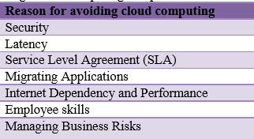

Source: The Organizational Critical Success Factors for Adopting Cloud Computing in SMEs

# Understanding cloud consumption models

Not all clouds offerings are the same. Even within a service provider, there are a wide range of options. However, services tend to fit into one of three consumption models.

## Infrastructure as a Service (IaaS)

Infrastructure as a Service (IaaS) is the most basic service. Providers offer compute, network, and/or storage resources that customers used on an on-demand basis. IaaS services are commonly used to provide extra or complimentary resources for workloads that are deployed by the customer, not the provider. IaaS providers allow customers to allocate resources in fairly complex architectures and then deploy the workloads of their choice, significantly lowering the bar on the cost, complexity, and time required to spin up a new service. When considering IaaS, it is important to consider service-level agreements (SLAs) provided by the vendor which should outline availability, scalability, performance, and maintenance policies. Data portability, user control, and security are also necessary considerations in an IaaS deployment.

## Platform as a Service (PaaS)

Platform as a Service (PaaS) is conceptually similar to IaaS and is a natural progression. With PaaS the on-demand environment is also configure with enabling software, such as a relational database system or map reduce architecture. PaaS enables agile deployment for efforts based on standard platforms while reducing the need for the customer to have specialized skill and experience with those architectures. A great example of PaaS would be Watson, IBM’s famous AI architecture, which IBM makes available via cloud services for research purposed. SMB organizations who once waited in queue for months for expensive supercomputer resources now que up for Watson with faster availability and lower cost than traditional approaches.

## Software as a Service

Software as a Service has was being offered long before the cloud architecture made it’s debut, but it’s now assumed that SaaS providers embrace the signature cloud infrastructure and offer the same agile benefits. For some types of application, a Software as a Service (SaaS) alternative may be desirable. In such a case, rather than an application migration, a SaaS option is a replacement of an existing on premise application and it is usually only data that needs migration. Removing the need for management of the application and infrastructure has cost saving potential and allows resources to be focused on the core competency of the business. For example, perhaps a SMB has an on premise Learning Management System (LMS), but the vendor now offers a cloud-based version of the same software. Migrating to the cloud-based version may be more cost effective and it’s likely the vendor will have services to accommodate the migration. D2L, an LMS provider based in Toronto offers free migration services for legacy customers. “We bend over backwards to make the migration as easy as possible for our customers,” says Jeremy Weinstein, Director for D2L Project Management Office, whose team manages customer migrations. “Having our customers in the cloud is the best option for both them and us.”

# Understanding cloud architectures

In general, there are four types of cloud architectures Pubic, Private, Community, and Hybrid. While SMB organizations most commonly leverage the public cloud, according to a survey published by [3], SMB organizations leverage all four types.

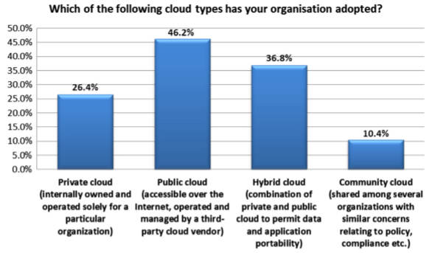

## Public Cloud:

This is what most people think of when referring to ‘the cloud’. Cloud computing resides outside an organization with a service provider, applications may be open to the public, and users access resources over the internet. These environments are typically multi-tenant, meaning multiple customers may share compute, network, and storage devices. Examples include Amazon Elastic Compute Cloud (EC2), Google AppEngine, and Windows Azure Services Platform.

## Private Cloud:

Private cloud architectures offer a cloud computing model operated only for one institution/organization. It can be managed internally or by a third party and hosted internally or externally. Access to applications is likely tightly controlled as data is proprietary and/or confidential to the organization.

Note that a private cloud can be provided in different configurations. A private cloud can be provisioned and managed exactly as a public cloud but on dedicated network, compute, and storage resources. AWS and other traditional public cloud providers offer this alternative. Conversely, for organizations who have security concerns that prohibit deployment in a shared datacenter, the private cloud approach can be deployed using on premise resources and application management software. Some offerings, like NetApp, focus on creating private gateways that create easily managed paths to the public cloud. Others, like HPE and IBM, are enabling their clients to offer the full public cloud experience from within the client’s data center to internal stakeholders, including the ability to “invoice” divisions/departments by utilization and to provision projects quickly on shared infrastructure. In short, there are a range of offerings in the marketplace.

The following chart was published by Forrester with their recent evaluation of on premise private cloud providers. The article explains the appropriate use case for each provider.

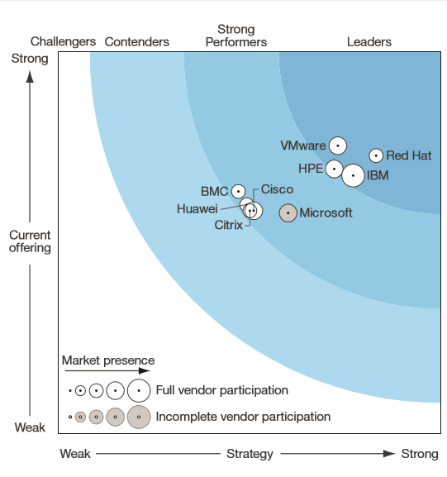

The Forrester Wave™: Private Cloud Software Suites

In addition to the benefits associated with public cloud, there are unique benefits of deploying private cloud [14]. A private cloud platform with quick application provisioning and flexible ‘charge back’ options, converts IT into a partner with all shareholders within the business. By leveraging the right private cloud provider, successful businesses gain higher reliability and avoid costly downtime for their critical applications. Leading organizations take advantage of the best private cloud management efficiency in order to know how their critical applications are operating and avoid issues that can lead to lost revenues. By working with a private cloud provider, leading organizations are able to offload many of the complications and day-to-day tasks of running critical applications while the provider will work carefully to maintain performance and avoid downtime and other issues to meet negotiated support levels.

All the various offerings are characterized by their own kind of risks. According to AWS, the deployment of resources on-premises, using virtualization and resource management tools, doesn’t provide many of the benefits of cloud computing but is sometimes sought for its ability to provide dedicated resources [4]. In most cases this deployment model is the same as legacy IT infrastructure while using application management and virtualization technologies to try and increase resource utilization. Several sources pointed out that the on premise configurations are more costly as the organization had to provide for periodic technology refreshes. On the other hand, on premise private cloud can offer all the benefits of public cloud while ensuring decisions around security remain firmly in the control of the organization [5].

## Community Cloud:

Community clouds feature different organizations with the same policies and requirements sharing the same cloud computing environment.

## Hybrid Cloud:

A combination of public, private and community cloud is called hybrid cloud.

# General MIGRATION APPROACH

In their paper “A comprehensive framework for cloud computing migration using Meta-synthesis approach”, the authors detail a comprehensive review of the literature to distill the optimal approach to cloud migration [6]. Their research identified seven stages for successful and addressed the risk areas and best practices associated with numerous migration efforts documented in the scholarly press. Reviewing their results and comparing to documentation available from AWS, Azure and commercial practitioners, their approach is both comprehensive and aligned with service-provider recommendations. Not surprisingly, the resulting approach bears striking resemblance to approaches for other large-scale IT efforts and share several common themes, even the terminology at first appears to differ. The one fact that seemed to be obscured in the discussion was that ‘migration’ to the cloud is not a straight-line, one-and-done, project but a portfolio of related efforts as the right migration strategy is mapped to each workload. The stages identified in the research are outlined below.

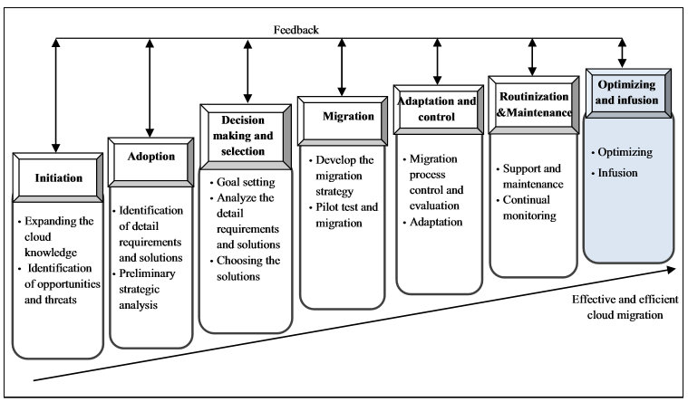

## Framework for Cloud Computing Migration

## Initiation

Initiation is basically a phase of the project when the organization educates itself about the key benefits, pitfalls, legal implications, and risks of migrating to the cloud. In this phase, leadership needs to shift from an ‘ownership’ mentality of having dominion over resources to a renter, or tenant, mentality with its associated loss of control. As stated previously, the best defense against a lock-in experience is developing an in-depth understanding of the options and the providers. The better the organization does preparing itself strategically, the more likely success will be. All approaches argue for a complete inventory of existing workloads as that will drive an understanding of the scope, requirements, and priorities for migration.

## Adoption

In this phase, the business is evaluating readiness and negotiating requirements and prioritization. The goal is to gain consensus on the overarching cloud strategy and garner the resources required to proceed with the migration. This is basically the phase to get executive leadership, business leadership, and technical leadership aligned and gain consensus on the high-level agreement to move to the cloud. For SMB, this may be a small set of core leaders.

## Decision Making and Selection

Use the information gathered to make a specific plan for specific workloads. Map your ‘current’ state to a ‘to be’ state, realizing this is a high-level strategic plan that will change. As noted before, most approaches present this as a one-and-done project, but the reality is that there are probably dozens of workloads that could be moved to the cloud and all should be evaluated and assigned a preliminary disposition. There are numerous potential service providers, numerous methods for migrating workloads, and numerous methods for migrating data, which will be discussed below. Each workload should receive a planned disposition.

## Migration

This would more accurately be called ‘Migration Planning’. Within the plan developed above, the business can develop a set of priorities for workload migrations along with a portfolio of related projects. Remembering the key ‘avoidance’ factors for moving to the cloud, use this phase to prioritize some “easier” efforts first to build confidence and competence, perhaps with a range of providers, before being required to commit critical workloads to migration paths that would be difficult to move later, creating a lock-in situation.

Develop detailed requirements for each workload prior to migration, paying special attention to compute, network, storage, and security needs. Look for forcing events, like license renewal deadlines, and take into consideration normal business cycles, like end-of-year and holiday schedules, in planning specific migration efforts.

For more complex efforts, consider hiring an experience partner or engaging the services group for the planned provider. SMB usually has less resources than larger Enterprise to support the migration effort, but assuming a successful migration can occur without some outside assistance and guidance may be unrealistic. Productivity gains, while completely expected, will not be realized until well after the migration.

The decision to use a professional service to manage the migration to cloud or to do it in house depends largely on the complexity of the migration. The process requires a deep understanding of the interaction between applications and the underlying infrastructure. Additionally, complex migrations require program management skills. Professional service providers bring both of these skill sets along with valuable experience.

## Adoption and Control

During this phase, the migration occurs and adjustments are made to control for any factors that threaten the original goals and requirements set forth for the migration. Monitor security, performance, and availability to insure service levels are appropriate. Adjust as needed.

## Routinization and maintenance

In this phase, the operational procedure are updated to reflect the new operating model. Some tasks will fall away, but others will simply change to appropriate tasks in the new environments. Runbooks, scripts, policies, and procedures will all need to be updated. Obviously, planning for this should have occurred along with skills acquisition to assure success.

## Optimization and Infusion

In this phase, achieve operational excellence and allow the new skills and experience to diffuse through your organization. Several authors noted that during these last two phases, organizations tend to mentally move on to the next big project, but to fully realize the value of their cloud strategy, care and attention must be invested at this phase to achieve maximum benefit.

The appendix to their published work contains a list of recommended steps cross-referenced to the literature which could easily be leveraged to create a detailed project plan supporting the migration.

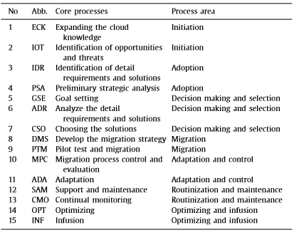

Key Substeps in the Migration Framework

The established providers, like AWS and Azure, offer free migration guidance and a range of paid service offerings. The AWS Cloud Adoption Framework (CAF) walks customers through a similar implementation model that covers not only the technical aspects of the migration effort, but the leadership and change management aspects as well. For SMB organizations, these resources enable an organization to complete a successful migration without all the resources available to a larger enterprise.

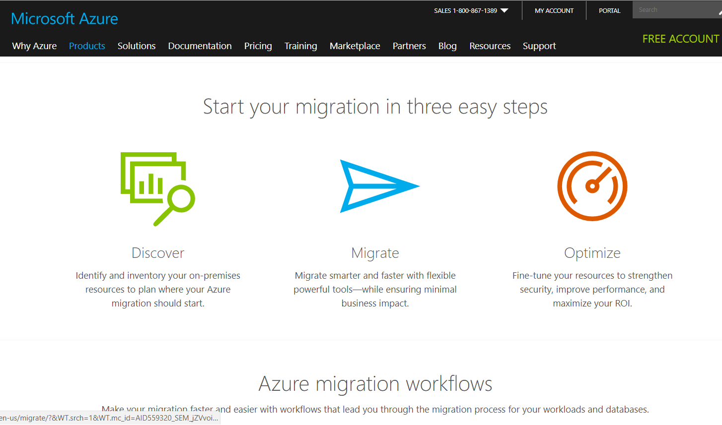

Azure Migration Website

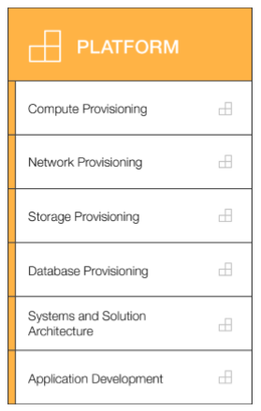

AWS Cloud Adoption Framework- Platform Perspective Capabilities

# Application Migration Methods

Applications can take several paths to get to the cloud, but in general there are six paths for an application to go from on premise to the cloud. A successful cloud strategy starts with application discovery and dependency mapping to obtain an accurate inventory of the diverse applications currently running in the datacenter. It’s important to understand each application in terms of:

* Application type and version
* Operating system version and patches
* Server, storage and networking characteristics
* Security profile and rules
* Interdependencies
* Performance
* Utilization cycles

Application architecture is a prime indicator of if and how an application can be migrated. Not every application is a suitable candidate for [cloud migration](https://www.cloudvelox.com/cloud-migration-services/). SMB organizations are likely to have legacy applications with outdated hardware and software dependencies. Problematic applications include legacy applications, such as those running on AS400 computers, applications with intensive CPU and/or I/O capacity needs, vendor application designs and licensing that lack the structure for a virtualized environment, and proprietary applications. While major public cloud providers are constantly offering new instance categories, they will never extend to outdated legacy or proprietary applications. According to, [Stephen Orban](https://medium.com/@stephenorban?source=post_header_lockup), who offers migration services, six common migration methods are [8]:

## Rehosting

Probably 40-60% of the application inventory will fall into this category. An on premise application can be shifted to a cloud-based version of the same application. In a legacy migration scenario where the organization is looking to scale its migration quickly to meet a business case, the application can be rehosted onto a cloud offering without extensive rearchitecting. Rehosting can be automated with tools (e.g. [AWS VM Import/Export](https://aws.amazon.com/ec2/vm-import/), [Racemi](http://www.racemi.com/free/)) and applications may be easier to optimize/re-architect once they’re already running in the cloud.

One rehosting tool that helps with this process is called CloudEndure[7]. This is a five-step process that begins with installing the CloudEndure software onto the machine that holds the application or servers that you would like to migrate. The CloudEndure software then gets pointed to the cloud service of your choice and it starts to clone your machine onto the new cloud server. This cloning process takes place behind the scenes and doesn’t require restarts or even any writing to disks, so it does not impact the performance of your production environment. It is also uses AES 256-bit encryption, so you can know that your data is secured in transit. Once the cloning process has been completed there is a testing phase that ensures that your application or data has migrated over flawlessly. The final phase is called a “Cutover”. This is the process where the CloudEndure software points users to the application on the cloud instead of the original one. This process allows downtime to be almost eliminated altogether.

## Replatforming

Similar to rehosting, but incorporating a few optimizations in order to achieve some tangible benefit, while not changing the core architecture of the application. For example, an SMB can reduce the amount of time managing database instances by migrating to a database-as-a-service platform like Amazon Relational Database Service ([Amazon RDS](https://aws.amazon.com/rds)). Another example would be, while moving an application to AWS, switch from WebLogic, which requires an expensive license, to [Apache Tomcat](http://tomcat.apache.org/), an open-source equivalent.

## Refactoring / Re-architecting

For proprietary applications, especially the business is using to generate customer revenue, the move to cloud can be invasive and expensive. This has been cited as an often overlooked cost in cloud migration strategy. In this scenario, an application has to operate in a totally different ecosystem such that, while the application provides the same features and function, the underlying architecture must undergo radical alteration. This transformation is typically driven by a strong business need to add features, scale, or performance that would otherwise be difficult to achieve in the application’s existing environment.

## Repurchasing

This is commonly a move from an on premise application to a SaaS platform providing similar functionality, such as moving from a home-grown CRM to[Salesforce.com](https://www.salesforce.com/), an on premise HR system to [Workday](https://www.workday.com/), or a Support case management system to Service Now. As mentioned earlier, most application providers either have SaaS versions available or are scrambling to do so.

## Retire

 As much as 10% of an enterprise IT portfolio is no longer useful, and can simply be turned off. Reaching out to business owners during the ‘inventory’ step can help identify applications that have simply never been removed.

## Retain

Doing nothing is usually short-term alternative. There can be business reasons why retaining the current version of an application is attractive, perhaps it was recently upgraded or it’s a known candidate for ‘retire’ on the term-term horizon. Only migrate what makes sense for the business; and, as the application portfolio shifts from on-premises to the cloud and your team gains experience, these remaining applications can be addressed in due course of time.

# Data Migration Options

Once the cloud architecture and provider are selected and a migration method is assigned, it’s time to consider how to move the data from its existing home to its new home. When it comes to migrating the data, the “best” method changes with the size of the data. If the data is under 1TB it can be sent encrypted online without too much difficulty or time delay, but if the application is mission critical, if the data is larger than 1TB, or the data change rate is high, a more sophisticated method may be required.

Again, there are multiple approaches and the approach is intimately related to the migration method, but a few common choices are outlined below.

**Just data migration.** For mission critical applications, the business generally can’t tolerate downtime. In this situation, the data migration strategy tends to rely on some sort of replication. Replication is a complex subject, but if available bandwidth between the current host and the intended host is greater than the rate of change of the data, replication may be a viable option for creating a copy of the data in the target environment. Once the copy is complete, the business can switch the application to the new host without much, or any, downtime. In some cases,the migration can be treated as a Disaster Recovery (DR) scenario. Replicate the entire stack from point source A to target B, establish replication, and then click the failover button to take down service at A and start service at B.

The issues arise when the data becomes larger. If you were to migrate 10TB of data over the internet using a standard 100Mbps connection, Product Manager at Google, Ben Chong, estimates the transfer would take 12 days [9]. If you scale this up to the petabyte level, the transfers would take multiple years. Data larger than 1TB and up to 30 TB should ultimately be stored in a single NAS appliances and shipped to the cloud provider. These appliances should be able to encrypt using either of 128-bit or 256-bit AES encryption [10]. They should also be configured with RAID so that the data is not destroyed or corrupted during transit. If you have more than 30TB of data you can ship multiple appliances to your cloud provider where they use large 10GB connections to download the data. When the data starts getting into the petabyte scale, there are other data transfer options. AWS has a service called Snowball and Google Cloud has a service called Google Transfer Appliance. These services are similar in the fact that each company sends custom server racks that can live in your data center for a few days and create a mirror of your data. They are then transferred by 18-wheeler (in AWS’s case) to the cloud facility. This form of transfer can speed up the transfer process from weeks to days for extremely large data sources [9,11].

**Machine replication**. This is suitable option for moving to an internal private cloud because there will be plenty of bandwidth. This option leverages the portability of VMware-based technology to replicate the entire stack. VMware allows you to package the entire VM/vApp into an OVF. The OVF can then be transported anywhere if you’re already on a virtualized physical server.

**P2V migration.** The concept involves virtualizing a physical app. VMware has a VMware converter that does P2V, and it’s very easy to go from a physical to a private cloud using P2V. However, this is an advanced approach and requires experience or extended research to make sure you have the latest updates, best practices and suggestions.

**Forklift Migration Strategy.** This is actually similar to rehosting as it addresses the application and the data at the same time with few alterations. If the application is latency sensitive, it is recommended to move the entire application and all of its parts to the cloud at the same time instead of one piece at a time. This would include the app, the data servers that it accesses, and the web service that it uses [11]. In the forklift strategy the bulk of the work lies in the configuration of IP addresses, security groups, and DNS to name a few. The application code can stay relatively intact with few alterations.

# Conclusion

Forbes released an article discussing the criteria for selecting a cloud provider. They summarized the challenge as follows [12]: “By choosing the wrong cloud provider, companies can get locked into an expensive and painful ordeal. Some providers have draconian severance clauses that make it nearly impossible to move to another provider if needed. The most critical component to consider when choosing a cloud provider is how they protect and secure data both at rest and in flight. Understanding the cloud provider’s data ownership and sovereignty policies is one of the key decision points when choosing a provider.”

Restricting selection to the top providers and educating leaders on cloud options, mitigaties the key fears concerning security risk and lock-in. Comparing security documents for top providers revealed a remarkable similarity between the security capabilities and features described by each [13,14,15]. Along with a list of compliance with other protocols, all have PCI DSS compliance for credit card processing. However, AWS was the only provider who stated they have Level 1 compliance, reserved for merchants with the highest volume of transactions, over 6 million card transactions per year. All three acknowledge that the organization retains ownership of data. All three offer data encryption at rest and in flight. All offer a robust set of tools for controlling policy-based access by user groups and services, retaining data within geographic boundaries as required by some countries, and implementation of high-availability options for disaster recovery and non-disruptive operation. In short, the cloud industry has matured with several stable, viable options with numerous product offerings. By increasing their understanding of and gaining experience with migrations, SMB organizations can prepare themselves or successful cloud migrating strategies.

# References:

1 Abdollahzadehgan, Azam. Hussin, Ab Razak Che. Gohary, Marjan Moshfegh . Amini, Mahyar. “The Organizational Critical Success Factors for Adopting Cloud Computing in SMEs.” Journal of Information Systems Research and Innovation p 67-74.

2 <https://www.cisco.com/c/dam/en/us/solutions/collateral/service-provider/global-cloud-index-gci/white-paper-c11-738085.pdf>. Cisco public.

3 Opara-Martins , Justice. Sahandi, Reza. Tian, Feng. “Critical analysis of vendor lock-in and its impact on cloud computing migration: a business perspective”. (April 2016). Journal of Cloud Computing: Advances, Systems and Applications

4 <https://irjet.net/archives/V4/i1/IRJET-V4I166.pdf>

5 <https://d0.awsstatic.com/whitepapers/aws-overview.pdf>

6 Bazi , Hamid resa. Hassanzadeh, Alireza, Moeini, Ali. “A comprehensive framework for cloud computing migration using Meta-synthesis approach”. (2017). The Journal of Systems and Software v128. P87-105

7 “Live Migration,” CloudEndure. [Online]. Available: https://www.cloudendure.com/live-migration/. [Accessed: 27-Nov-2017].

8 <https://medium.com/aws-enterprise-collection/6-strategies-for-migrating-applications-to-the-cloud-eb4e85c412b4>

9 B. Chong, “Introducing Transfer Appliance: Sneakernet for the cloud era,” Google Cloud Platform Blog, 18-Jul-2017. [Online]. Available: https://cloudplatform.googleblog.com/2017/07/introducing-Transfer-Appliance-Sneakernet-for-the-cloud-era.html. [Accessed: 22-Nov-2017].

10 New Tech ForumBy Howard Young,InfoWorld|Jul 26, 2017About | Emerging tech dissected by technologists and H. Y. I. W. J. 26 2017, “Best practices for migrating data to the cloud,” InfoWorld, 26-Jul-2017. [Online]. Available: https://www.infoworld.com/article/3211244/cloud-computing/best-practices-for-migrating-data-to-the-cloud.html. [Accessed: 22-Nov-2017].

11 J. Varia, “Migrating your Existing Applications to the AWS Cloud,” Oct-2010. [Online]. Available: https://d0.awsstatic.com/whitepapers/cloud-migration-main.pdf. [Accessed: 2017].

12 <https://www.forbes.com/sites/moorinsights/2016/07/28/cloud-is-not-a-business-strategy-choose-your-provider-wisely/#773331fb1949>

13 Overview of Amazon Web Services, April 2017

14 https://docs.microsoft.com/en-us/azure/security/azure-security

15 Safeguarding the cloud with IBM Dynamic Cloud Security Maintain visibility and control with proven security solutions for public, private and hybrid clouds, downloaded from IBM web site

1. Authors are all candidates in the Master of Data Science program at Southern Methodist University.